PAL: PHASE ALTERNATE LINE

The PAL system is used in U.K, Europe, Australia and South Africa. PAL is

an integrated method of adding colors to a black-and-white television signal

that paints 625 lines at a frame rate of 25 frames per sec. Like NTSC, the

even and odd lines are interlaced, each field taking 1/50

th

of a sec to draw

(50Hz).

SECAM: SEQUENTIAL COLOR AND MEMORY

The SECAM system is used in France, Russia, and a few other countries.

Although SECAM is a 625-line, 50Hz system, it differs greatly from both

the NTSC and the PAL color systems in its basic technology and broadcast

method. Often, however, TV sets sold in Europe utilize dual components

and can handle both PAL and SECAM systems.

HDTV: HIGH DEFINITION TELEVISION

There are six video formats in the ATSCD (Advanced Television Systems

Committee) TV standard that are “HDTV”. They are the 1080-line by 1920-

pixel formats at all picture rates (24, 30, 60 pictures per sec) and the 720-line

by 1280-pixel formats at these same picture rates. All of these formats have

a 16:9 Aspect Ratio.

HDTV provides high resolution in a 16:9 aspect ratio. This aspect ratio

allows the viewing of cinema scope panavision movies. There is a

contention between the broad cast and computer industries about whether to

use interlacing or progressive-scan technologies. The broadcast industries

has promulgated an ultra-high-resolution, 1920*1080 interlaced format to

become the corner stone of a new generation of high-end entertainment

centers, but the computer industry would like to settle on a 1280*720

progressive-scan system for HDTV. While the 1920*1080 provides more

pixels than the 1280*720 standard, the refresh rates are quite different. The

higher-resolution interlaced format delivers only half the picture every 1/60

of a sec and because of the interlacing on highly detailed images there is a

great deal of screen flicker at 30Hz. The computer people argue that the

picture quality at 1280*720 is superior and steady. Both formats have been

included in the HDTV standard by ATSC (Advanced Television Systems

Committee).

PAL: PHASE ALTERNATE LINE

The PAL system is used in U.K, Europe, Australia and South Africa. PAL is

an integrated method of adding colors to a black-and-white television signal

that paints 625 lines at a frame rate of 25 frames per sec. Like NTSC, the

even and odd lines are interlaced, each field taking 1/50

th

of a sec to draw

(50Hz).

SECAM: SEQUENTIAL COLOR AND MEMORY

The SECAM system is used in France, Russia, and a few other countries.

Although SECAM is a 625-line, 50Hz system, it differs greatly from both

the NTSC and the PAL color systems in its basic technology and broadcast

method. Often, however, TV sets sold in Europe utilize dual components

and can handle both PAL and SECAM systems.

HDTV: HIGH DEFINITION TELEVISION

There are six video formats in the ATSCD (Advanced Television Systems

Committee) TV standard that are “HDTV”. They are the 1080-line by 1920-

pixel formats at all picture rates (24, 30, 60 pictures per sec) and the 720-line

by 1280-pixel formats at these same picture rates. All of these formats have

a 16:9 Aspect Ratio.

HDTV provides high resolution in a 16:9 aspect ratio. This aspect ratio

allows the viewing of cinema scope panavision movies. There is a

contention between the broad cast and computer industries about whether to

use interlacing or progressive-scan technologies. The broadcast industries

has promulgated an ultra-high-resolution, 1920*1080 interlaced format to

become the corner stone of a new generation of high-end entertainment

centers, but the computer industry would like to settle on a 1280*720

progressive-scan system for HDTV. While the 1920*1080 provides more

pixels than the 1280*720 standard, the refresh rates are quite different. The

higher-resolution interlaced format delivers only half the picture every 1/60

of a sec and because of the interlacing on highly detailed images there is a

great deal of screen flicker at 30Hz. The computer people argue that the

picture quality at 1280*720 is superior and steady. Both formats have been

included in the HDTV standard by ATSC (Advanced Television Systems

Committee).

**Course Outcome to be mentioned which is mapped with this lecture topic.**

CO5 :- To perform different operations on videos.

**Reading Material of this lecture topic.**

**BROADCAST VIDEO STANDARDS**

BROADCAST VIDEO STANDARDS: Four broadcast and video standards and recording formats are commonly in use around the world: NTSC, PAL, SECAM and HDTV. Because these standards and formats are not easily interchangeable, it is important to know where your multimedia project will be used. A video cassette recorded in the U.S will not play on a television set in a European country, even though the recording method and style of the cassette is “VHS.” Likewise, tapes recorded in European PAL or SECAM formats will not play back on an NTSC video cassette recorder. Each system is based on a different standard that defines the way information is encoded to produce the electronic signal that ultimately creates a television picture. Multi format VCRs can play back all three standards but typically cannot dub from one standard to another; dubbing between standards still requires high-end, specialized equipment.

NTSC: NATIONAL TELEVISION STANDARDS COMMITTEE The U.S, Japan, and many other countries use a system for broadcasting and displaying video that is based up on the specifications set forth by the 1952 National Television Standards Committee. These standards define a method for encoding information in to the electronic signal that ultimately creates a television picture. As specified by the NTSC standard, a single frame of video is made up of 525 horizontal scan lines drawn onto the inside face of a phosphor-coated picture tube every 1/30th of a sec by a fast-moving electron beam. The drawing occurs so fast that your eye perceives the image as table. The electron beam actually makes two passes as it draws a single video frame, first laying down all the odd-numbered lines, then all the even numbered lines. Each of these passes (which happen at a rate of 60 per sec, or 60Hz) paints a field. The process of building a single frame from two fields is called interlacing, a technique that helps to prevent flicker on television screens. Remember that computer monitors use progressive-scan technologies and draw the lines of an entire frame in a single pass, with out interlacing them.

PAL: PHASE ALTERNATE LINE The PAL system is used in U.K, Europe, Australia and South Africa. PAL is an integrated method of adding colors to a black-and-white television signal that paints 625 lines at a frame rate of 25 frames per sec. Like NTSC, the even and odd lines are interlaced, each field taking 1/50th of a sec to draw (50Hz).

SECAM: SEQUENTIAL COLOR AND MEMORY The SECAM system is used in France, Russia, and a few other countries. Although SECAM is a 625-line, 50Hz system, it differs greatly from both the NTSC and the PAL color systems in its basic technology and broadcast method. Often, however, TV sets sold in Europe utilize dual components and can handle both PAL and SECAM systems.

HDTV: HIGH-DEFINITION TELEVISION There are six video formats in the ATSCD (Advanced Television Systems Committee) TV standard that are “HDTV”. They are the 1080-line by 1920pixel formats at all picture rates (24, 30, 60 pictures per sec) and the 720-line by 1280-pixel formats at these same picture rates. All of these formats have a 16:9 Aspect Ratio. HDTV provides high resolution in a 16:9 aspect ratio. This aspect ratio allows the viewing of cinema scope Panavision movies. There is a contention between the broad cast and computer industries about whether to use interlacing or progressive-scan technologies. The broadcast industries have promulgated an ultra-high-resolution, 1920*1080 interlaced format to become the corner stone of a new generation of high-end entertainment centres, but the computer industry would like to settle on a 1280*720 progressive-scan system for HDTV. While the 1920*1080 provides more pixels than the 1280*720 standard, the refresh rates are quite different. The higher-resolution interlaced format delivers only half the picture every 1/60 of a sec and because of the interlacing on highly detailed images there is a great deal of screen flicker at 30Hz. The computer people argue that the picture quality at 1280*720 is superior and steady. Both formats have been included in the HDTV standard by ATSC (Advanced Television Systems Committee).

**Video Recording and Editing in Multimedia**

* Photographic images that appear to be in full motion and are played back at speeds of 15 to 30 frames per second. The term video refers to a moving image that is accompanied by sound, such as a television picture. Of course, text can be included in videos, either as captioning for spoken words or as text embedded in an image, as in a slide presentation. The following programs are widely used to view videos: Real Player, Window Media Player, etc.
* It is a way of storing television programs and other moving images along with sound. Video recording is used to record TV programs for later broadcast. Video recording also gives viewers the ability to save a TV program and watch it whenever they want to.
* It is a recording of both the visual and audible components (especially one containing a recording of a movie or television program) synonyms: video.
* It is an effective way of comprehensively capturing raw contextual data where conditions and resources permit. Video recording can help you capture important nonverbal communication cues in contextual data.
* The terms audio and video commonly refers to the time-based media storage format for sound/music and moving pictures information. Audio and video digital recording, also referred as audio and video codecs, can be uncompressed, lossless compressed, or lossy compressed depending on the desired quality and use cases.
* As per the features of video recording it has 5 types
  + Battery Capacity. Battery capacity is very important to keep in mind as you're filming. ...
  + Audio Inputs. Lower end cameras typically only accept one audio source, and usually from an 1/8th inch audio jack. ...
  + Video Outputs. ...
  + Ergonomics. ...
  + Image Control.
* A digital video recorder comes with its own internal hard drive and users can start recording without the need to insert any sort of storage media. When it comes to analog camera recording, digital video recording supports features such as remote access motion detection, real-time playback, recording and backup.
* 5 Problems when making a video
  + Bad sound. It hurts to see so many videos out there that suffer from this.
  + Wrong delivery formats. Knowing what format you require a video in is very important.
  + Miscommunication of a brief.
  + Changing a brief half way through the process.
  + Filming doesn't go to plan.
* 7 Different Types of Video Cameras and Their Uses
  + Type 1: DSLR Video Cameras.
  + Type 2: Mirror less Video Cameras.
  + Type 3: Point-And-Shoot Video Cameras.
  + Type 4: Professional-Grade Film Cameras.
  + Type 5: Sports and Action Video Cameras.
  + Type 6: 360-Degree Video Cameras.
  + Type7: Digital Camcorders.
* If you want record a video on Windows Click the camera icon to take a simple screenshot or hit the Start Recording button to capture your screen activity. Instead of going through the Game Bar pane next time, you can also just press Win + Alt + R to immediately start your recording.
* As per video editing is the manipulation and arrangement of video shots. Video editing is used to structure and present all video information, including films and television shows, video advertisements and video essays.
* Parts of a Video Camera?
  + Lens. The lens on a video camera serves as the same function as a still camera's lens.
  + Viewfinder. The viewfinder is directly connected to the lens and is meant to provide access to the image for the user.
  + Microphone.
  + Recorder.
  + Controls.
  + Battery.



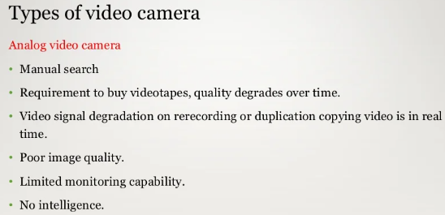

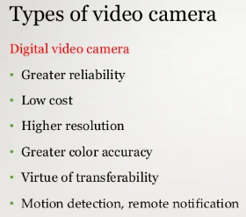

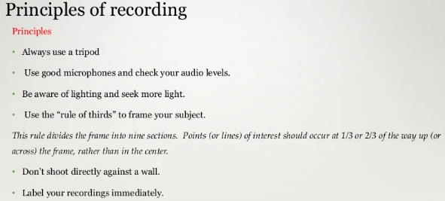



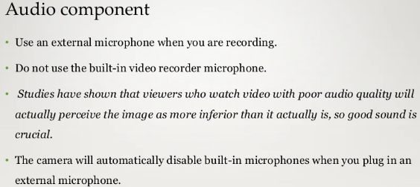

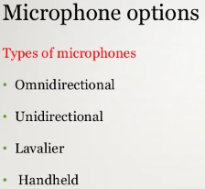

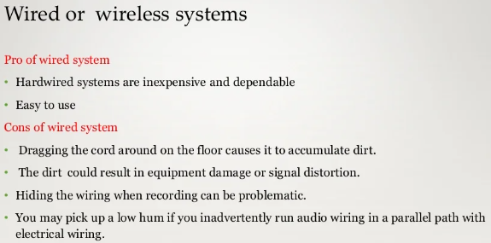







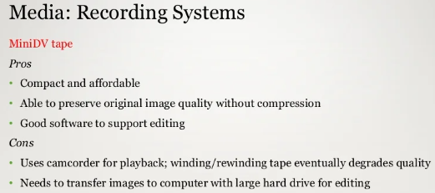

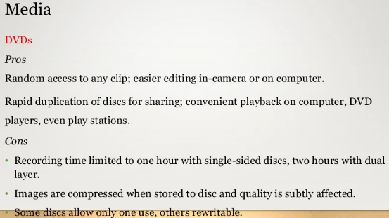

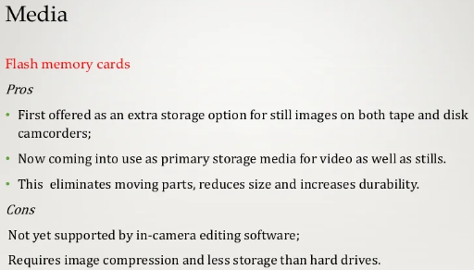

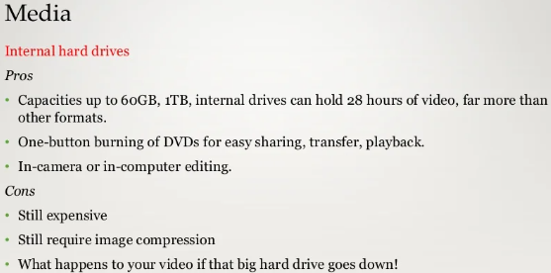

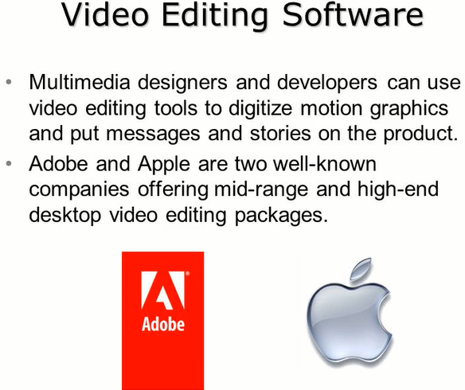

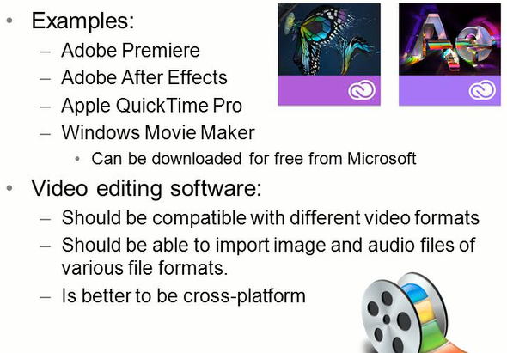

**Tape Formats**

A tape recording format is defined as **the relationship between data which is sent to or received from a tape device and the physical representation of that data on the recording medium**. The recording format consists of factors like: Recording density (Bits per inch, BPI) The number of tracks used.

Today, a modern tape cartridge can hold **15 terabytes**. And a single robotic tape library can contain up to 278 petabytes of data. Storing that much data on compact discs would require more than 397 million of them, which if stacked would form a tower more than 476 kilometers high.

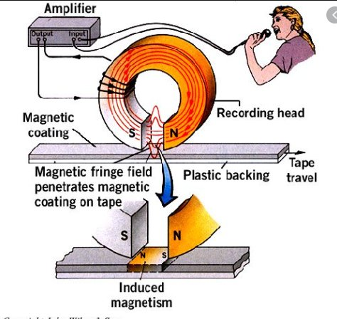

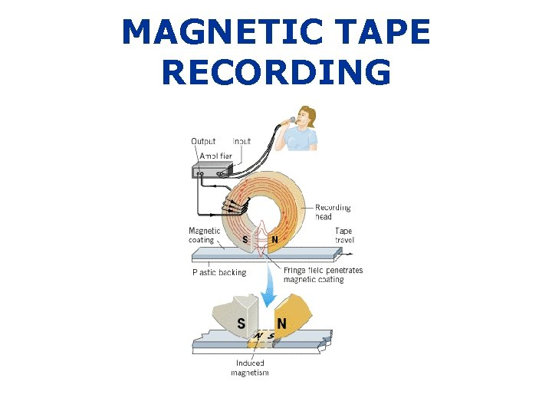

Videotape is **magnetic tape** used for storing video and usually sound in addition. Information stored can be in the form of either an analog or digital signal. Videotape is used in both video tape recorders (VTRs) and, more commonly, videocassette recorders (VCRs) and camcorders.

Tape is a narrow strip being magnetized on one side of the strip. To store data, **the narrow strip goes through below the magnetic head which stores the data into bits**. Various data are stored on the strip. It helps in storing digital information.

Magnetic tape recording works by **converting electrical audio signals into magnetic energy, which imprints a record of the signal onto a moving tape covered in magnetic particles**. Playback is achieved by converting the recording on tape back into electrical energy to be amplified.

The recording medium for the tape recording process is typically made by **embedding tiny magnetic oxide particles in a plastic binder on a polyester film tape**. Iron oxide has been the most widely used oxide, leading to the common statement that we record on a "ribbon of rust".

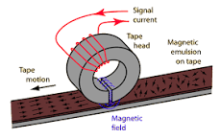

Tape is a narrow strip being magnetized on one side of the strip. To store data, **the narrow strip goes through below the magnetic head which stores the data into bits**. Various data are stored on the strip. It helps in storing digital information.

Most videotapes consist of **a layer of tiny magnetic particles applied to Mylar, a strong, flexible plastic material**. About a billion magnetic particles cover a square inch of tape and function like microscopic bar magnets. When the tape passes over an electromagnet, information is recorded and played back.

**Magnetic Tape memory**

Magnetic drums, magnetic tape and magnetic disks are types of magnetic memory. These memories use property for magnetic memory. Here, we have explained about magnetic tape in brief.

In magnetic tape only one side of the ribbon is used for storing data. It is sequential memory which contains thin plastic ribbon to store data and coated by magnetic oxide. Data read/write speed is slower because of sequential access. It is highly reliable which requires magnetic tape drive writing and reading data.

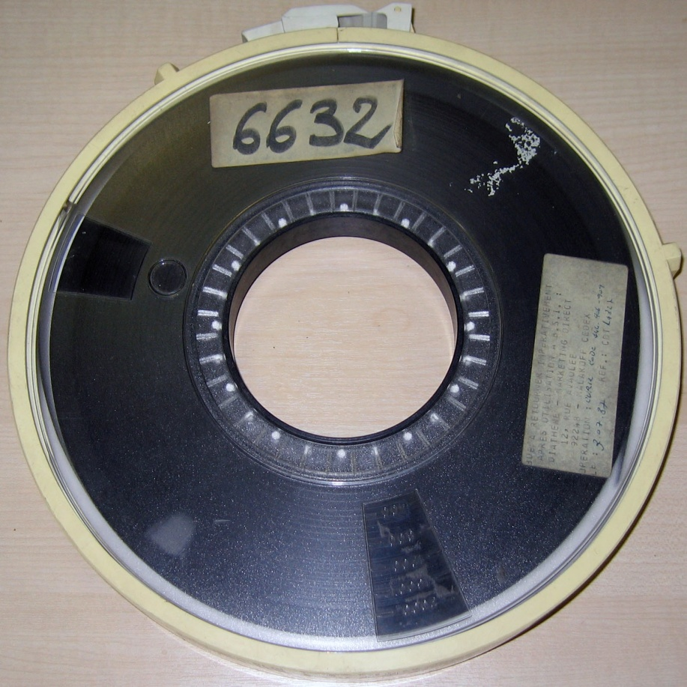

The width of the ribbon varies from 4mm to 1 Inch and it has storage capacity 100 MB to 200 GB.

Let’s see various advantages and disadvantages of Magnetic Tape memory.

**Advantages :**

1. These are inexpensive, i.e., low cost memories.
2. It provides backup or archival storage.
3. It can be used for large files.
4. It can be used for copying from disk files.
5. It is a reusable memory.
6. It is compact and easy to store on racks.

**Disadvantages :**

1. Sequential access is the disadvantage, means it does not allow access randomly or directly.
2. It requires caring to store, i.e., vulnerable humidity, dust free, and suitable environment.
3. It stored data cannot be easily updated or modified, i.e., difficult to make updates on data.

Differences between Magnetic Tape and Magnetic Disk

Magnetic Tapes and Magnetic Disks are the types of [magnetic memory](https://www.geeksforgeeks.org/secondary-memory/). Both are called non-volatile storage and used to store data.   
**Magnetic tape** contains thin plastic ribbon is used for storing data. It is a sequential access memory. So the data read/write speed is slower. It is mainly used for data backups.

**Magnetic Disk** contains circular disk made of metal or plastic. Both sides of the disk are usually used for storing data. The disk is coated with magnetic oxide. The disk is divided into multiple concentric circles known as tracks and tracks are divided into sectors in which data are stored.

Let’s see the difference between Magnetic Tape and Magnetic Disk:

|  |  |  |
| --- | --- | --- |
|  | **Magnetic Tape** | **Magnetic Disk** |
| 1. | Plastic ribbon serves as the primary component of Magnetic tape memory. | The metal or plastic circular disk having coating of magnetic oxide serves as the key component of Magnetic disk memory. |
| 2. | The cost of magnetic tape is less. | The cost of magnetic disk is high. |
| 3. | Reliability of magnetic tape is less. | Reliability of magnetic disk is more. |
| 4. | Access time for magnetic tape is more. | Access time for magnetic disk is less. |
| 5. | Data transfer rate for magnetic tape is comparatively less. | Data transfer rate for magnetic disk is more. |
| 6. | Magnetic tape is used for backups. | Magnetic disk is used as a secondary storage. |
| 7. | In magnetic tape data accessing rate is slow. | In magnetic disk data accessing rate is high or fast. |
| 8. | In magnetic tape data can’t be updated after fed-up of data. | In magnetic disk data can be updated. |
| 9. | Magnetic tape is more portable. | Magnetic disk is less portable. |
| 10. | Magnetic tape contains reels of tape which is in form of strip of plastic. | Magnetic disk contains round platters which is made up of plastic or metal. |
| 11. | 1 track is kept for parity check in magnetic tapes so it is not used for storing data. | In magnetic disk, the topmost surface of top plate and bottommost surface of last plate in a platter are not used for storing data as scratching issue can be there for both surfaces. |
| 12. | In magnetic tape for data recording, magnetic material is coated on only one side of the tape. | While in magnetic disk for data recording, magnetic material is coated on both side of the platters. |
| 13. | Tape drives are used for reading and writing of data from magnetic tapes. | Disk drives are used for reading and writing of data from hard disks. |
| 14. | The storage components of magnetic tapes, are in contact with external devices in tape drives. | Magnetic discs are not touched by any external devices |
| 15. | Hold less data as compared to magnetic disk. | Capacity to hold more data per unit volume. But these need to be kept in a  vacuum in order to reduce air friction. |
| 16. | Storing of data takes place in the form of records in magnetic tapes that are further organized in blocks. | Storing of data takes place in the form of files, folders or directories on the disk. |

* ***Relevant Video links for this lecture topic.***
* [Analog Video and Digital Video in Multimedia | lecture 2 - YouTube](https://www.youtube.com/watch?v=Y5a43s0mXto)
* ***Any web-link to be attached relevant to the topic.***

[Analog or Digital Video: What's the difference? (meijitechno.com)](https://meijitechno.com/analog-or-digital#:~:text=Analog%20or%20Digital%20Video%3A%20What%27s%20the%20difference%3F%20The,leading%20to%20a%20general%20loss%20of%20video%20quality.)

* **TEXT BOOKS**

1. **Tay Vaughan, “Multimedia making it work”, Tata McGraw-Hill, 2008.**
2. **Rajneesh Aggarwal & B. B Tiwari, “Multimedia Systems”, Excel Publication, New Delhi, 2007.**
3. **Li & Drew, “Fundamentals of Multimedia”, Pearson Education, 2009.**

* **REFERENCE BOOKS**

1. **Parekh Ranjan, “Principles of Multimedia”, Tata McGraw-Hill, 2007**
2. **Anirban Mukhopadhyay and Arup Chattopadhyay, “Introduction to Computer Graphics and Multimedia”, Second Edition, Vikas Publishing House.**